**Simple Calculator LAB**

**Addition:**

**Output :**

**Subtract:**

**Output :**

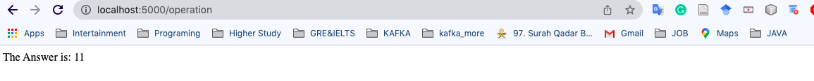

**Multiplication:**

**Output :**

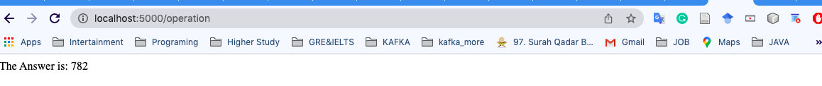

**Division**

**Output :**

**GitHub link:**

**https://github.com/faysalmazeddiu/faysalmazeddiu.github.io/tree/main/simple_calculator**

**App.js :**

const express=require('express');

const bodyParser = require('body-parser');

const app=express();

var path=require("path");

app.use(express.static(path.join(__dirname,"public")))

const urlencoded=express.urlencoded({ extended: false })

app.get('/',(req,res)=>{

res.status(200).sendFile(path.join(__dirname,"public","calculator.html"));

});

app.post('/operation',urlencoded,(req,res)=>{

var result=0;

if (req.body.operation==='add') {

result=Number(req.body.first_number)+Number(req.body.second_number);

}else if (req.body.operation==='subtract') {

result=Number(req.body.first_number)-Number(req.body.second_number);

}else if (req.body.operation==='division') {

if (Number(req.body.first_number)>Number(req.body.second_number)) {

result=Number(req.body.first_number)/Number(req.body.second_number);

}else{

result="First Number should be greater than second Number"

}

}else if (req.body.operation==='multiply') {

result=Number(req.body.first_number)*Number(req.body.second_number);

}

res.send("The Answer is: "+result);

})

app.listen(5000,()=>{

console.log("Server is started on port:"+5000);

});